GIT STASH:

Stash means to store (changes) safely in a hidden place (the stash stack). Stashing the current working directory's staged or unstaged changes or untracked files and then storing them in the stash stack reverts the current working directory to the last commit

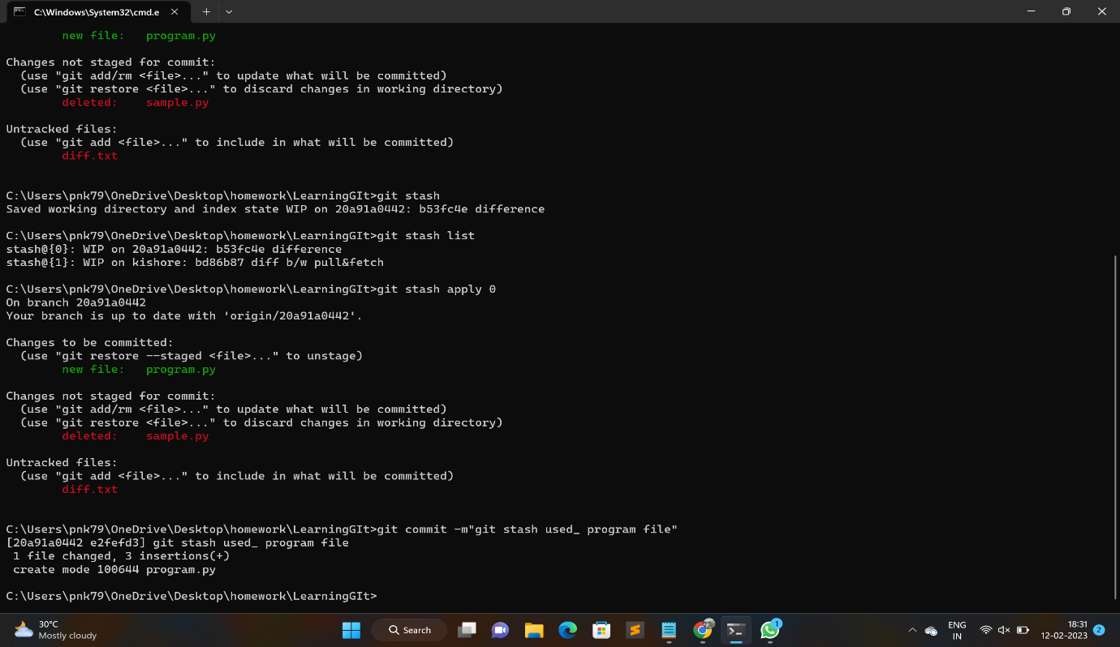

GIT FETCH:When you do a git fetch, it fetches all the changes from the remote repository and stores it in a separate branch in your local repository. You can reflect those changes in your corresponding branches by merging.

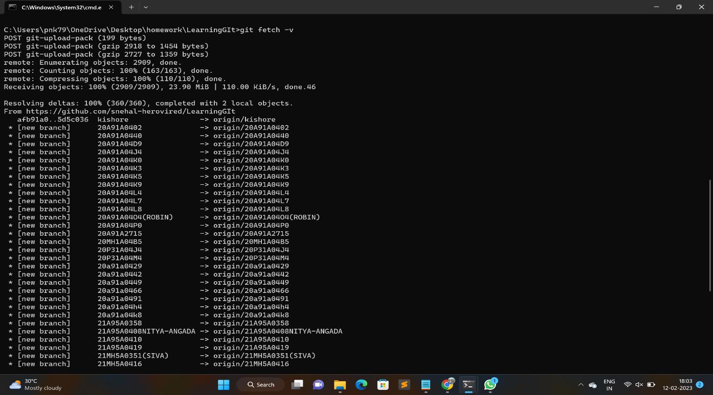

DIFFERNCE BETWEEN FETCH & PULL :

Git Fetch is the command that tells the local repository that there are changes available in the remote repository without bringing the changes into the local repository. Git Pull on the other hand brings the copy of the remote directory changes into the local repository

GIT MERGE:

Merging is Git's way of putting a forked history back together again. The git merge command lets you take the independent lines of development created by git branch and integrate them into a single branch. Note that all of the commands presented below merge into the current branch.

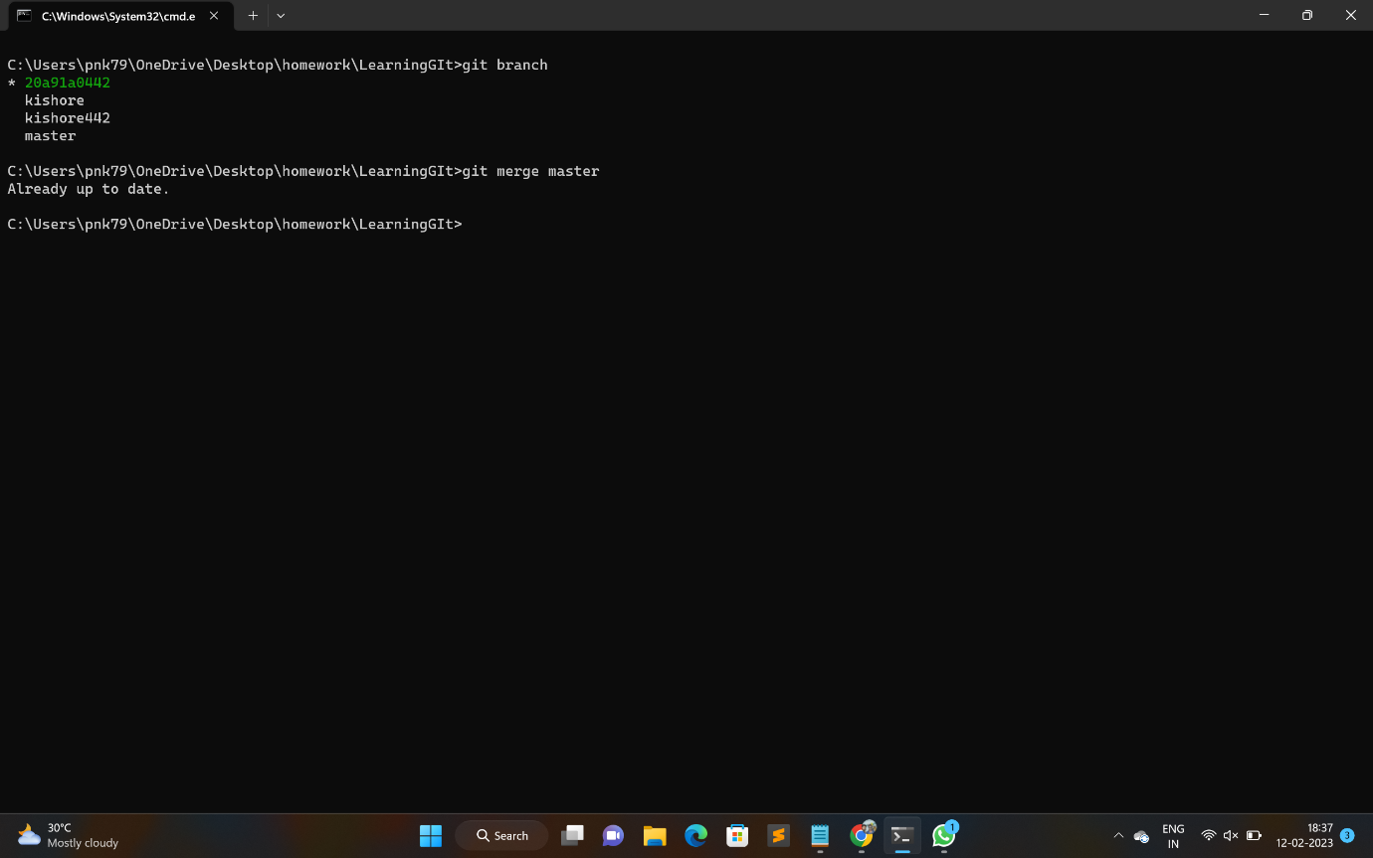

TO SHOW HIDDEN FILES IN LINUX:

In Linux and Unix-like systems, if a file or directory (folder) name starts with a period (.), then the file becomes hidden by default. To see all hidden files in Linux run ls -al command.

For example:

nani.txt is a test file to hide this file follow below steps

mv nani.txt .nani.txt # nani.txt is hide

ls -a # to see hidden file

AWK COMMANDS:

The awk command is a Linux tool and programming language that allows users to process and manipulate data and produce formatted reports. The tool supports various operations for advanced text processing and facilitates expressing complex data selections.

1.AWK operations

a.scans a file line by line

b.splits each input line intofields

2. useful for

a.Transfer data files

b. produce formatted reports

3. programming constructs

a.arthimatic string operations

b.conditional and loops

